AWS LAB 1

HTTP Server Access

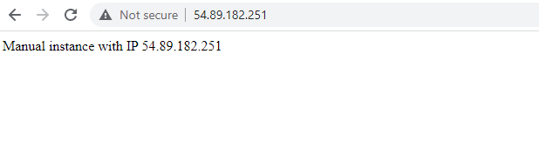

HTTPSERVER1 Instance:

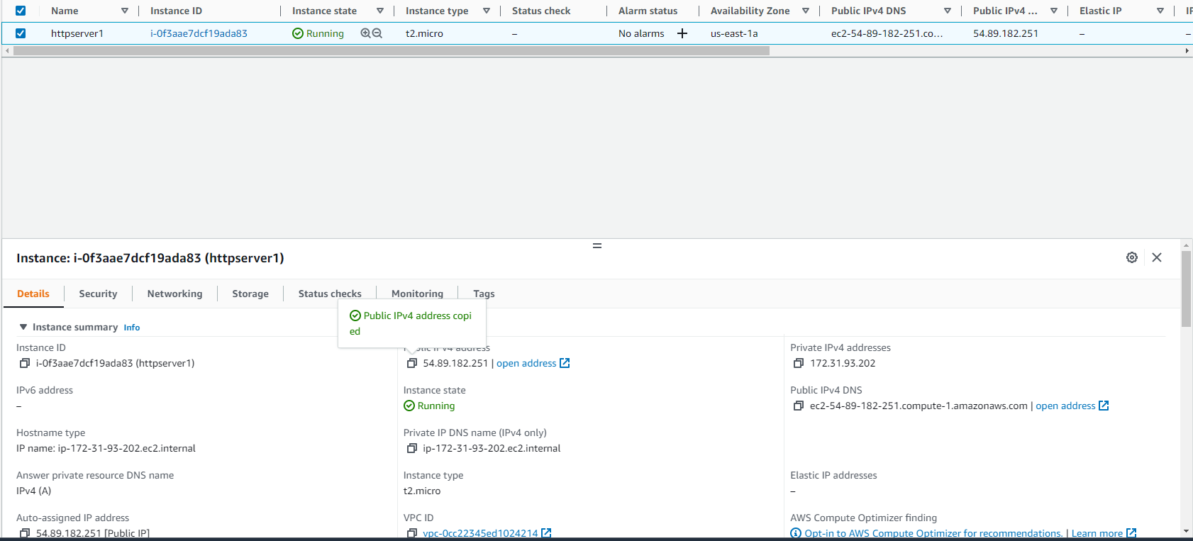

AWS LAB 2

Load Balancer

